**Exercise**

**1.** int x,y,z,w;

x = scanf("%d %d %d",&y,&z, &w);

A. What happen if input was 2 integer values from the keyboard?

**Jawab**: Maka x = 2, karena menunggu input ke-3.

B. What is x value if 3-character values given as the input?

**Jawab**: Maka x = 0, karena input tidak valid/error.

**2**. char ss1[40];

char ss2[40];

x = scanf("%s %s",ss1,ss2);

A. What is ss1 and ss2, if the input from keyboard is "Good morning everyone"?

**Jawab**: ss1 = "Good", ss2 = "morning", x = 2**.**

B. What is x if the input: "Class 1PAT"?

**Jawab**: ss1 = "Class", ss2 = "1PAT", x = 2**.**

**3**. char ss[40];

scanf("%4s", ss);

What is ss value, if the input: "**Good morning**"?

**Jawab**: maka akan print/output ss = “Good”**.**

**4**. char ch;

ch = getchar();

What is ch value, if the input: **Binus?**

**Jawab**: maka akan print/output ch = ’B’

**5. char ch1, ch2;**

**ch1 = getchar(); // input word "Binus" here!**

**ch2 = getchar();**

What is the value of ch1 and ch2, if the input: Binus?

**Jawab**: ch1 = ’B’ dan ch2 = ’i’.

**6.** Create a program in C to receive input from standard input (keyboard) for the following data:

- Assignment Score

- Mid Exam Score

- Final Exam Score

Calculate and display **Final Score** using: **Final Score = 20%*Assignment + 30%*Mid + 50%*Final**

Program/code:

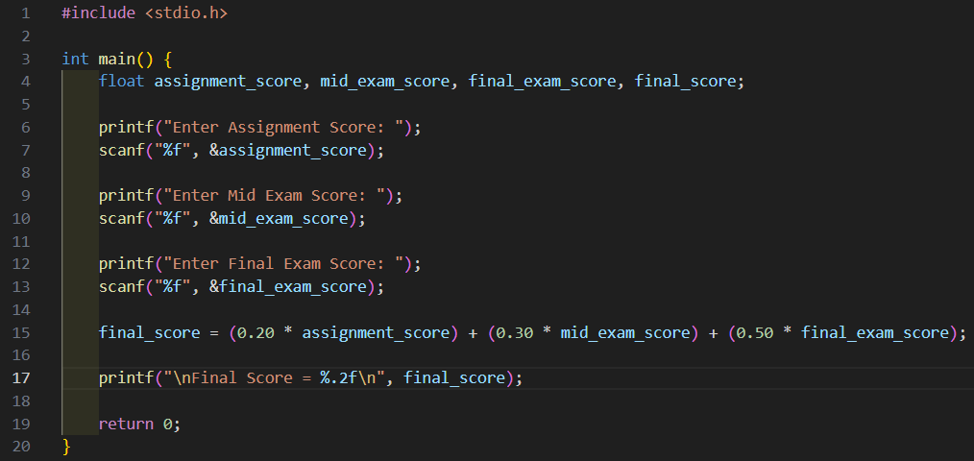

Run:

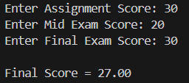

**7. Jawab:**  Karena **scanf("%d", &nim); meninggalkan newline (\n) di buffer**, sehingga saat getchar() dipanggil, yang terbaca adalah \n, bukan input.

**8. Jawab:** Maka output akan menghasilkan,

|  |
| --- |
| 10 % 3 = 1  10 % 3 = 1  Welcome to Binus everyone  Welcome to Binus everyone |